Abstract

In this study, I investigate the region Serengeti-Mara of the country Tanzania. It is a famous area for its great wildebeest migration. But habitat fragmentation and human-wildlife conflict threaten a critical big cat population and other wildlife. This is a problem that cannot go untouched as it will affect the ecosystem as a whole. And so you can’t fix the problem if you can’t observe it. In this study, we will study the migration of wildebeest in the Serengeti region, observe the migration itself among other factors such as geographical location, rivers, lakes, biomass distribution among the area, the protected area of Serengeti-Mara, the livestock and its path surrounding the area. With this, we can correlate those factors to the migration of animals throughout the years. This study is inspired by the previous study about vegetation and migration and how it interacts “Simulating the East African wildebeest migration patterns using GIS and remote sensing” by Douglas E. Musiega and Sanga-Ngoie Kazadi.

Introduction

In East Africa, the Serengeti-Mara spans between Tanzania and Kenya. It is a globally renowned hotspot for biodiversity and it is also one of the last remaining intact wilderness areas on Earth. Central to it ecological significance is the Great Migration, involving millions of wildebeest. This ecosystem harbors a rich diversity of wildlife, the migration also plays a crucial role in shaping ecosystem processes such as nutrient cycling therefore influencing the structure and function of the entire ecosystem. However, right now it faces numerous environmental challenges, it raises concerns about the long-term sustainability of the Great Migration and the ecological integrity of the Serengeti-Mara landscape

In this paper, we are going to observe the Greate Migration in the Serengeti-Mara ecosystem. By shedding light on the dynamics of migration and environmental interactions in this iconic landscape, this paper seeks to deepen our understanding of the ecological processes driving one of nature's greatest spectacles and to inform holistic conservation approaches for safeguarding the Serengeti-Mara ecosystem for future generations.

Methodology

The study was conducted in the Serengeti-Mara ecosystem, spanning approximately 30000 km square across northern Tanzania and southwestern Kenya.

Data collection: We got the data from various sources such as the Serengeti GIS & Data website. Which include CSV files and shapefiles about the vegetation of the land and other information.

The website collects data through:

* GPS Tracking: Tehy collated GPS tracking data from collars fitted on a sample of migratory ungulates, including wildebeest to monitor their movement throughout the 4 seasons of the year. The GPS collars were distributed across multiple herds across different regions of the Serengeti-Mara ecosystem.
* Aerial Survey: Conducted during peak migration seasons to estimate the distribution and the amount of migration herds using aircraft
* Remote sensing: Measure areas like rainfall and biomass. Obtained satellite image
* Field Observations: conducted by trained field researchers to document the presence and behavior of migratory herds.

Data analysis: Using GIS. The systems that were used for data analysis is the ArcGIS Online, Map Viewer, and Map Viewer Classic. Using its layers to create multiple overlaying data for visualization of the correlation between aspects if the Great Migration

* Spatial Analysis: GIS was used to extract data from CSV files or to extract specific information necessary to understand the migration. It maps migration routes, finds patterns of migratory herds
* World Imagery: It use satellite imagery like Sentinel, Landsat, and MODIS.One meter or better satellite and aerial imagery in many parts of the world. The map includes 15-meter TerraColor imagery at small and mid-scales (~1:591M down to ~1:288k) for the world. The map features Maxar imagery at 0.3-meter resolution for select metropolitan areas around the world, 0.5-meter resolution across the United States and parts of Western Europe, and 0.6-1.2-meter resolution imagery across the rest of the world. In addition to commercial sources, the World Imagery map features high-resolution aerial photography contributed by the GIS User Community. This imagery ranges from 0.3-meter to 0.03-meter resolution, down to ~1:280 in select communities.

Result

Through the data found, we can conclude that the ecosystem in Serengeti-Mara has been changing as the number and position of wildebeest migration throughout 2012-2018 have changed. However, it is not a complete change but rather a gradual shift. Overall we can still observe that the migration path of wildebeest still matches the previously established path from the 2000s.

Here we can see a comparison between the summer of 2017 versus the summer of 2013:

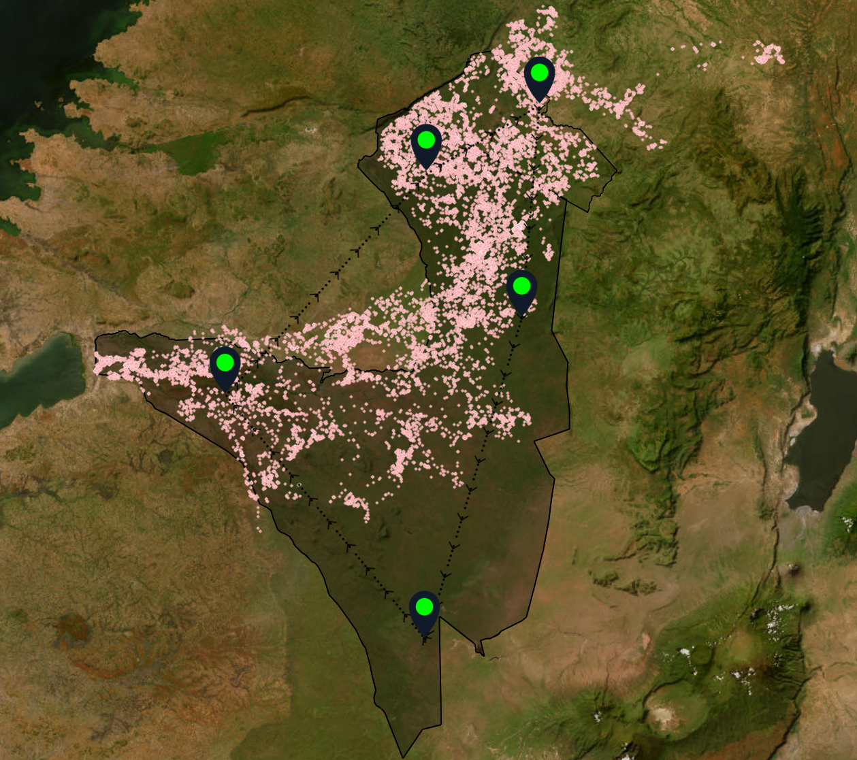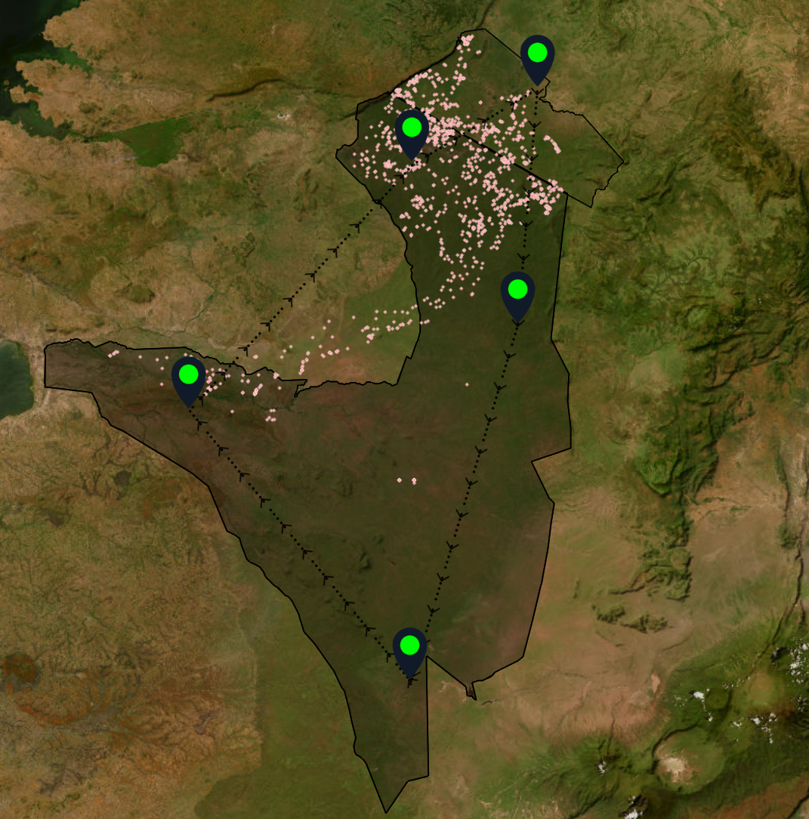

Fig 1: Migration of Summer 2017 Fig 2: Migration of Summer 2013

As we see the location of migration is relatively the same but the amount of animals in those migrations has been increasing drastically through those 5 years. Another clear example for this is the migration of Spring 2018 and Spring 2014:

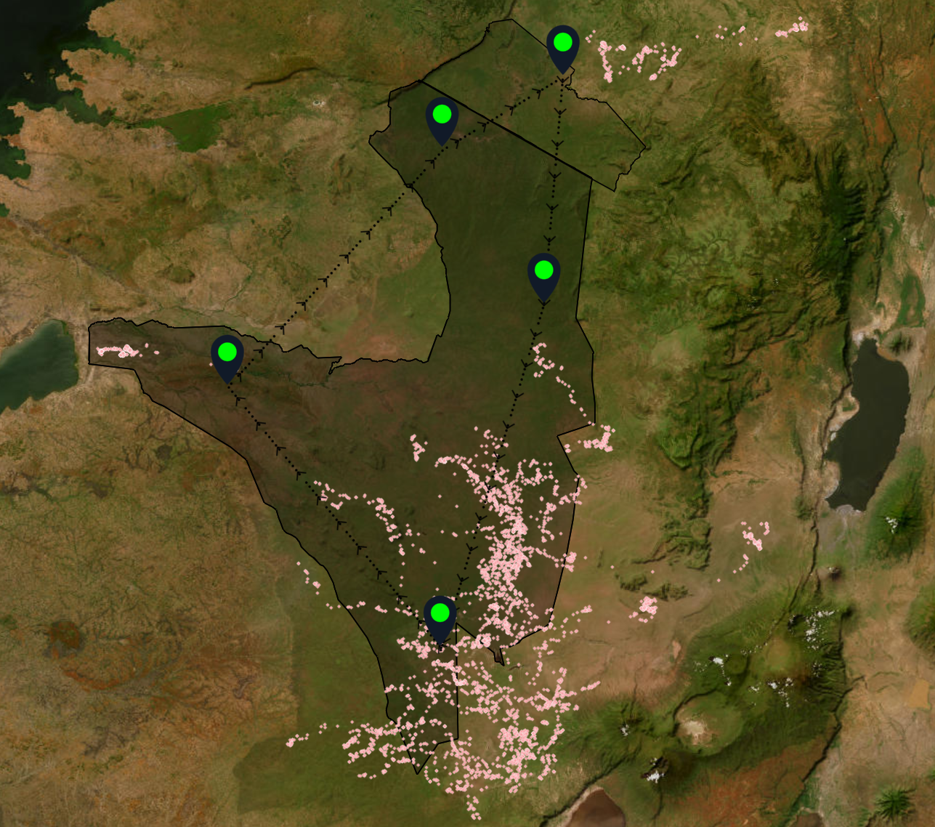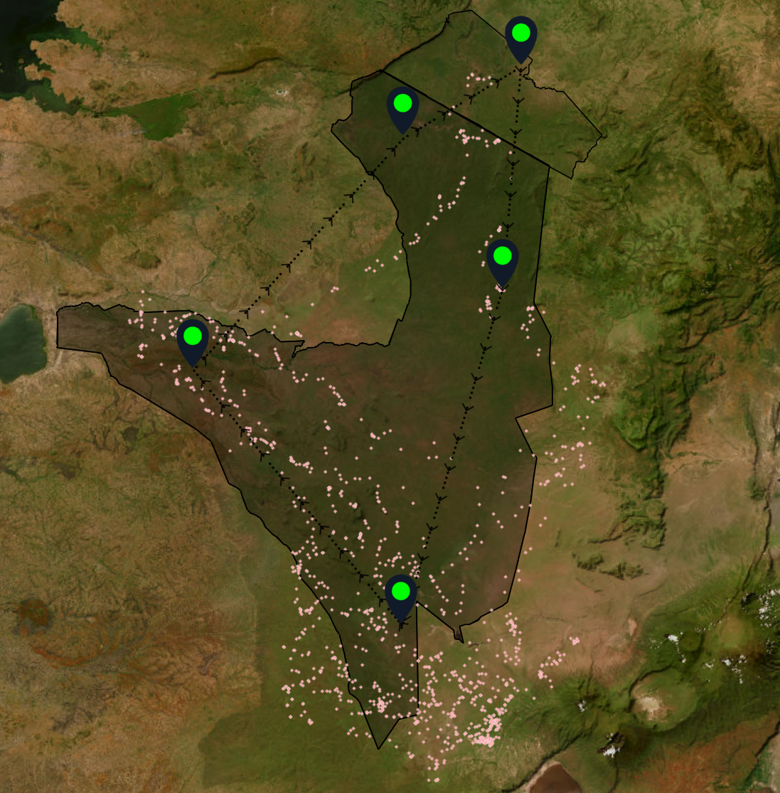

Fig 3: Migration of Spring 2018 Fig 4: Migration of Spring 2014

These changes in number could be correlated with the livestock and biomass of Serengeti-Mara as it surrounds the migrations.

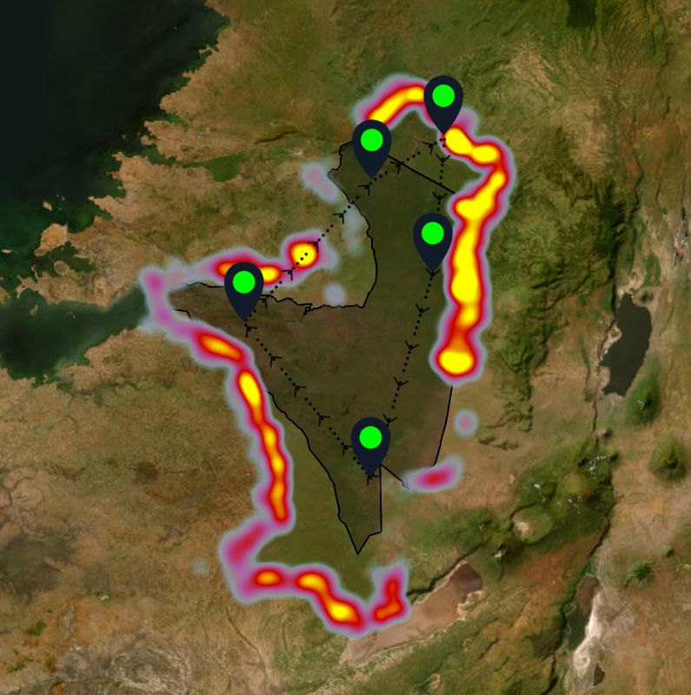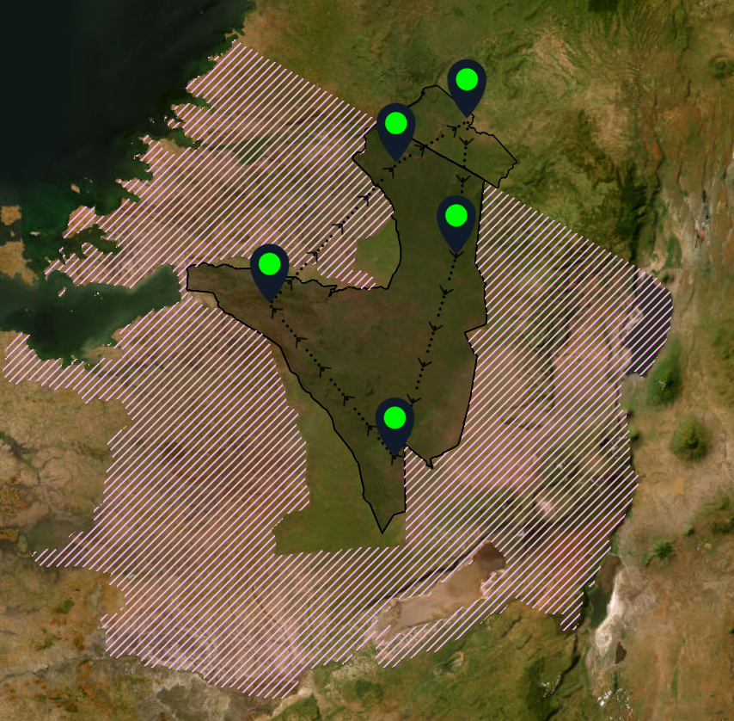

Fig 5: Biomass distribution Fig 6: Livestock of the Serengeti

For the next steps after this observation were made. We’d like to look into the direct correlation between the biomass and vegetation of the Serengeti-Mara from the pass years with numbers and formulas and draw more specific conclusion from it and not just speculation.

Conclusion

In conclusion, the study provides valuable insight into the dynamics of migration throughout the year and the environmental element surrounding it. The study contributes to the growing body of knowledge on migration and environmental interactions in the Serengeti-Mara ecosystem and highlights the importance of preserving the iconic landscape for future generations.

Reference

* Data Dryad: https://datadryad.org/resource/doi:10.5061/dryad.b303788
* Veldhuis MP, Ritchie ME, Ogutu JO, Morrison TA, Beale CM, Estes AB, Mwakilema W, Ojwang GO, Parr CL, Probert J, Wargute PW, Hopcraft JGC, Olff H (2019) Cross-boundary human impacts compromise the Serengeti-Mara ecosystem. Science 363(6434): 1424-1428. <https://doi.org/10.1126/science.aav0564>
* Veldhuis MP, Ritchie ME, Ogutu JO, Morrison TA, Beale CM, Estes AB, Mwakilema W, Ojwang GO, Parr CL, Probert J, Wargute PW, Hopcraft JGC, Olff H (2019) Data from: Cross-boundary human impacts compromise the Serengeti-Mara ecosystem. Dryad Digital Repository. <https://doi.org/10.5061/dryad.b303788>
* Musiega, D. E. (n.d.). Wiley Online Library | Simulating the East African wildebeest migration patterns using GIS and remote sensing, https://onlinelibrary.wiley.com/